

**PROJECT REPORT**

**OLX Clone**

Submitted in partial fulfillment of the requirement for the

4th Semester of

**MASTER IN COMPUTER APPLICATION**

**TO**

**RK UNIVERSITY, RAJKOT**

**Submitted By**

Student Name :- Rutvik Kamani Enrollment No : 22SOECA21028

Under The Guidance Of

**Internal Guide External Guide Head of Department**

Nirav Pandya, Dhvanil Trivedi Dr. Paresh Tanna

Assistant Professor, Owner, BCA/MCA Department,

RK University, KoderXpert Technologies, School of Engineering,

Rajkot Gandhinagar - Gujarat RK University, Rajkot



**SCHOOL OF ENGINEERING, RK UNIVERSITY, RAJKOT**

**DECLARATION**

We hereby certify that we are the sole author(s) of this project work and that neither any part of this project work nor the whole of the project work has been submitted for a degree to any other University or Institution. We certify that, to the best of my/our knowledge, our project work does not infringe upon anyone’s copyright nor violate any proprietary rights and that any ideas, techniques, quotations, or any other material from the work of other people included in my/our project document, published or otherwise, are fully acknowledged in accordance with the standard referencing practices. We declare that this is a true copy of my/our project work, including any final revisions, as approved by my/our project review committee.

**Signature of Student Signature of faculty**

Date :- 04/05/2024

Place :- RK University - Rajkot



**CERTIFICATE**

This is to certify that the work which is being presented in the Project Report entitled **“OLX Clone”,** in partial fulfilment of the requirement for the completion of **Master of Computer Application** and submitted to the School of Engineering, RK University, is an authentic record of my our own work carried out during a period from **January 2024 to May 2024.**

The matter presented in this Project Report has not been submitted by me us for the award of any other degree elsewhere.

**Signature of Student (S)**

Name :- Rutvik Kamani _________________

Enrollment No :- 22SOECA21028

This is to certify that the above statement made by the student(s) is correct to the best of my knowledge.

**Internal Guide External Guide Head of Department**

Nirav Pandya, Dhvanil Trivedi Dr. Paresh Tanna

Assistant Professor, Owner, BCA/MCA Department,

RK University, KoderXpert Technologies, School of Engineering,

Rajkot Gandhinagar - Gujarat RK University, Rajkot

May 2024



**SCHOOL OF ENGINEERING, RK UNIVERSITY, RAJKOT**

**Internship Offer Letter**

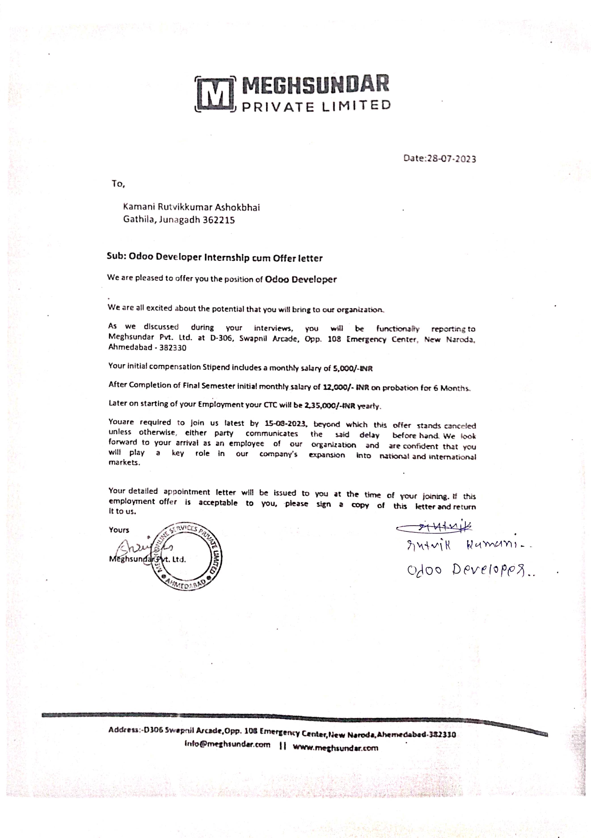

**Internship Complition Certificate**

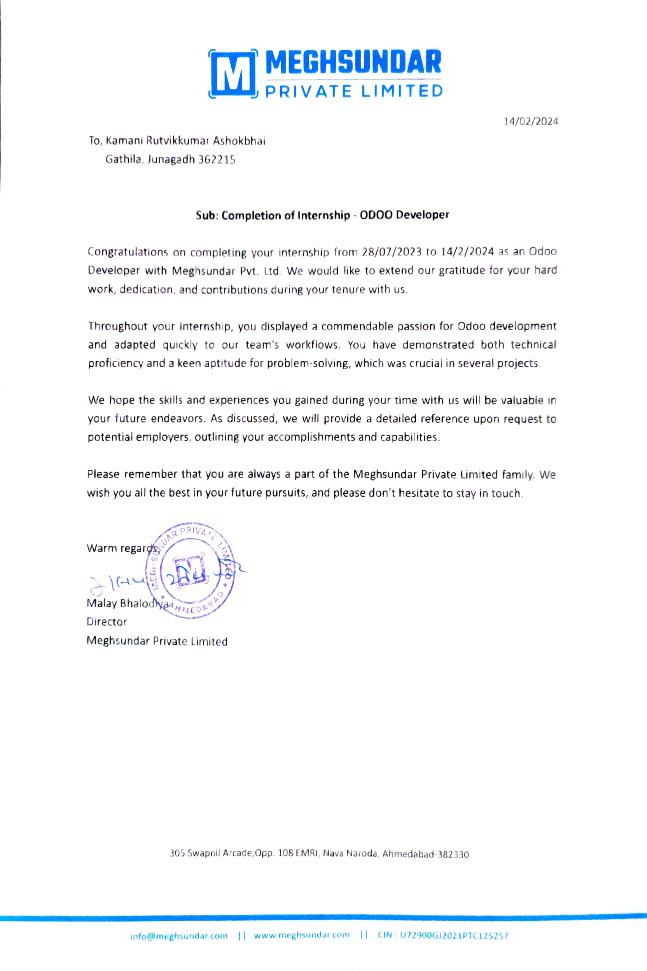

**Table Of Contents**

|  |  |
| --- | --- |
| **TITLE** | **PAGE NO** |
| * Acknowledgement | 05 |
| * Abstract | 06 |
| * Introduction | 07 |
| * Project management | 08 |
| * Project planning and schedule | 08 |
| * Schedule representation | 09 |
| * System requirement study | 10 |
| * User characteristics | 10 |
| * Hardware | 11 |
| * System analysis | 12 |
| * Study of current system | 12 |
| * Feasibility study | 12 |
| * Data dictionary | 13 |
| * Use case diagram | 14 |
| * ER Diagram | 15 |
| * Data modelling | 16 |
| * System design | 17 |
| * Flow chart | 17 |
| * Testing | 19 |
| * Test plan | 19 |
| * Testing strategy | 19 |
| * Testing methods | 20 |
| * Testing cases | 21 |
| * Screen short | 22 |
| * Limitation & future enhancement | 29 |
| * Conclusion and discussion | 30 |
| * References | 31 |

**Acknowledgement**

* We would like to express our heartfelt gratitude to OLX for serving as a tremendous source of inspiration for our project.
* OLX has revolutionized the online classifieds marketplace, setting a benchmark for user-friendly interfaces and efficient buying/selling experiences.
* We extend our sincere appreciation to the developers, designers, and entire team behind OLX for their dedication and innovation, which has motivated us to create our own version.
* While our platform may be a homage to OLX, we strive to infuse it with our unique features and enhancements to cater to the evolving needs of our users.

**Abstract**

* The OLX clone project aims to replicate the functionality and user experience of the popular online classified platform, OLX.
* Our goal is to provide users with a seamless platform for buying and selling a wide range of products and services in their local communities.
* The OLX clone project aims to empower users with a user-friendly platform for trading goods and services within their communities, fostering a convenient and efficient marketplace experience.

**Introduction**

* **OLX Clone** is useful for online exchange of the used things like if one user of the system wants to sell used products then user has to simply put all necessary information of that product on this platform and if some another user of the system want to buy that product then he has to simply contact to the seller of that product.
* So, In this way every seller can able to sell their products very easily. And every buyer gets good products of his choice. In short, this system provides medium where user can sell their used products and buyer can easily buy used products in a very short time period.

**Project Management**

* Project planning and schedule
  + Project planning and scheduling for an OLX clone involves breaking down the development process into manageable tasks, setting timelines for each task, and allocating resources effectively to ensure timely completion of the project. Here's a basic outline of project planning and scheduling for an OLX clone:
    - **Define project scope and objectives:** Clearly outline the goals and features of the OLX clone. Determine what functionalities will be replicated from OLX and any additional features you plan to incorporate.
    - **Identify tasks and milestones:** Break down the development process into smaller tasks such as database design, user interface design, backend development, frontend development, testing, deployment, etc. Define milestones to mark significant progress points in the project.
    - **Create a project timeline:** Develop a project timeline or Gantt chart that visualizes the sequence of tasks, their durations, and dependencies. Set deadlines for milestones and ensure they align with the overall project timeline.
    - **Assign responsibilities:** Assign responsibilities to team members for each task and ensure clarity on roles and expectations. Foster effective communication and collaboration among team members to ensure smooth progress.
    - **Iterative development:** Adopt an iterative development approach where the project is developed and tested in stages. Conduct regular reviews and iterations to incorporate feedback and make necessary adjustments to the project plan.
    - **Deployment and maintenance:** Plan for the deployment of the OLX clone platform once development is complete. Allocate time for final testing, user training, and post-launch support. Consider ongoing maintenance and updates to keep the platform secure and up-to-date.
    - **Documentation and evaluation:** Document the project plan, including all tasks, timelines, and resource allocations. Conduct a post-project evaluation to assess the project's success, identify lessons learned, and make recommendations for future projects.
* Schedule representation

|  |  |  |  |  |
| --- | --- | --- | --- | --- |
| Development Time | January | February | March | April |
| Preliminary Inventory |  |  |  |  |
| System Analysis |  |  |  |  |
| System Design |  |  |  |  |
| Coding |  |  |  |  |
| Testing |  |  |  |  |

**System Requirement Study**

* User characteristics
  + Understanding the user characteristics for an OLX clone is crucial for designing a platform that meets the needs and preferences of its target audience. Here are some key user characteristics to consider:
    - **Diverse Demographics:** OLX typically attracts users from a wide range of demographics, including different age groups, occupations, and socio-economic backgrounds. Your OLX clone should be designed to accommodate this diverse user base.
    - **Buyers and Sellers:** Users of the OLX clone can be categorized into buyers and sellers. Buyers are individuals looking to purchase products or services, while sellers are individuals or businesses offering items for sale. Understanding the motivations, preferences, and behaviors of both buyer and seller personas is essential for creating a balanced marketplace experience.
    - **Local and Global Users:** OLX serves users both locally and globally, allowing people to buy and sell items within their communities or across borders. Consider the needs of users who prefer local transactions as well as those who are interested in international trade.
    - **Mobile Users:** With the increasing popularity of smartphones, many users access online marketplaces like OLX through mobile devices. Ensure that your OLX clone is optimized for mobile use, with a responsive design and mobile-friendly features.
    - **Trust and Safety Concerns:** Trust and safety are paramount for online marketplaces. Users want assurance that their transactions are secure and that they are dealing with reputable sellers. Implement features such as user ratings, reviews, and secure payment options to build trust among users.

**Hardware**

* Recommended hardware
* To run the application system in the computer the minimum configuration required is as below:
* Multi-core processor
* 8 GB or more for better performance
* SSD for faster data retrieval
* Recommended software
* The configuration of the system which is used for the development such as coding and testing is given as below :
* Any OS System
* Visual Studio
* Mysql or any Database

**System Analysis**

* Study of current system
  + System Study is a Problem-Solving technique that decomposed a system into its component pieces for the purpose of the studying how well those component parts work and interact to accomplish their purpose.
  + According to the Merriam-Webster dictionary, systems analysis is the process of studying a procedure or business in order to identify its goals and purposes and create systems and procedures that 5ill achie1e them in an efficient Way.
  + Analysis and synthesis, as scientific methods, always go hand in hand; they complement one another. Every synthesis is built upon the results of a preceding analysis, and every analysis requires a subsequent synthesis in order to verify and correct its results.
* Feasibility study
  + Whatever we think need not be feasible. It is wise to think about the feasibility of any problem we undertake. Feasibility is the study of impact, which happens in the organization by the development of a system. The impact can be either positive or negative. When the positives nominate the negatives, then the Page 16 of 55 system is considered feasible. Here the feasibility study can be performed in two ways such as technical feasibility and Economical Feasibility.
  + The developing system must be justified by cost and benefit. Criteria to ensure that effort is concentrated on project, which will give best, return at the earliest. One of the factors, which affect the development of a new system, is the cost it would require.
  + Since the system is developed as part of project work, there is no manual cost to spend for the proposed system. Also all the resources and already available, it given an indication of the system is economically possible for development.
* Data Dictionary
  + **Database :-** olx

Table :- User

|  |  |  |  |
| --- | --- | --- | --- |
| **No** | **Name** | **Type** | **Constructor** |
| 1 | Id | int(20) | Primary Key |
| 2 | First_Name | Varchar(150) |  |
| 3 | Last_Name | Varchar(150) |  |
| 4 | Email | Varchar(150) |  |

Table :- Item

|  |  |  |  |
| --- | --- | --- | --- |
| **No** | **Name** | **Type** | **Constructor** |
| 1 | Id | Int(20) | Primary key |
| 2 | Item_name | Varchar(150) |  |
| 3 | Price | Int(10) |  |
| 4 | Model_year | Varchar(4) |  |
| 5 | Photo | Varchar(100) |  |
| 6 | Description | Longtext |  |
| 7 | Seller_id | Int(10) | Foreign key |
| 8 | Mobile | Varchar(10) |  |
| 9 | Date | Datetime(6) |  |
| 10 | City | Varchar(15) |  |
| 11 | Area | Varchar(20) |  |
| 12 | Category | Varchar(20) |  |

Table :- Contact

|  |  |  |  |
| --- | --- | --- | --- |
| **No** | **Name** | **Type** | **Constructor** |
| 1 | Name | Varchar(255) |  |
| 2 | Phone | Varchar(13) |  |
| 3 | Email | Varchar(100) |  |
| 4 | Content | Longtext |  |
| 5 | Time Stemp | Datetime(6) |  |

* Use case diagram

Use case diagram for user

User

Use-case-diagram for Admin

Admin

* ER Diagram

User

Contact

Product

* Data Modelling
* A data model shows the client’s information needs and business processes through entities, relationships and data required within the system. It complements the data flow diagram which shows how the data is processed.
* Data models can be conceptual (high level entities and relationships to document business concepts or high Level requirements), logical (more detailed information on entities, attributes and relationships by often expanding the conceptual model to include attributes, columns, fields and keys) or physical (how data is stored and managed in an application).
* Data models are diagrams supported by textual descriptions. They can include people, places, things, concepts, attributes and relationships. Textual descriptions are usually included dictionary.

**System Design**

* Flow Chart
* 0 Level

Admin

Buyers

Seller

* 1 Level

Admin

* 2 Level

User

**Testing**

* Software testing is the process of evaluating and verifying that a software product or application does what it is supposed to do. The benefits of testing include preventing bugs, reducing development costs and improving performance.
* Test Plan
* Like any project, the testing also should be driven by a plan. The test plan generates the report for the execution and tracking of the entire testing project.
  + Preparing the test plan
  + What needs to be the tested-the scope of testing, including clear identification of what will be the tested & what will not be tested.
  + How the testing is going to be performed -breaking down the testing into small and manageable tasks and identifying the strategies to be used for carrying out the tasks.
  + Resource needed for testing.
  + The timelines by which the testing activities will be performed.
  + Risks that may be faced in all of the above, with appropriate Page 25 of 55 mitigation and contingency plans.
* Testing Strategy
* Writing a Test Strategy effectively is a skill that every tester should achieve in their career. It initiates your thought process that helps to discover many missing requirements. Thinking and test planning activities help the team to define the Testing scope and Test coverage.
* It helps Test managers to get the clear state of the project at any point. The chances of missing any test activity are very low when there is a proper test strategy in place.
* Test execution without any plan rarely works. I know teams who write strategy document but never refer back while test execution. The Testing Strategy plan must be discussed with the whole team so that the team will be consistent with its approach and responsibilities.
* In tight deadlines, you can’t just waive any testing activity due to time pressure. It must at least go through a formal process before doing so.
* Testing methods
* Testing methodologies are the strategies and approaches used to test a particular product to ensure it is fit for purpose. Testing methodologies usually involve testing that the product works in accordance with its specification, has no undesirable side effects when used in ways outside of its design parameters, and will fail safely in the worst-case scenario.
* As software applications get ever more complex and intertwined and with the large number of different platforms and devices required to test, it is more important than ever to have a robust testing methodology.
* Without the proper development and testing methodologies for modern software, projects will inevitably go over budget, take longer than necessary, and not meet stakeholder expectations.
* Two Types of Testing

1. Blackbox Testing

Blackbox Testing can be used to validate the report meets all the specified requirements. Testers can review the report against the project objectives and deliverables to ensure that they are adequately addressed.

1. Whitebox Testing

Whitebox Testing for a project report involves examining the structure and organization of the document. Testers analyse how well the report is structured, including the logical flow of sections, of information, and the overall organization.

* Testing Cases

|  |  |
| --- | --- |
| **Test Case Specification** | **Description** |
| Test Case ID | Unique ID to identify/report the bug if present in the functionality of software |
| Test Case Objective | The purpose of the test. The lists can be generated to perform intended task for which software is developed. Results should always follow the test case objective |
| Pre-requisite | This can include environment setup, supporting software environment setup. for the project, or any fields in which user will give the input. So that test cases can be planned accordingly. |
| Steps | This includes steps to be performed to give the input to the system, so that system can perform its specified task and display the result accordingly. If automated testing is used, then, these steps are translated to the scripting language of the tool. |
| Input Data | The choice of input data will be depended on the test case itself and the technique followed in the test case. For E.X. equivalence partitioning, boundary value analysis etc. |
| Expected Result | It can be the user required output to be shown |
| Actual Result | This step should do a comparison of the expected and actual results to highlight any differences. |
| Status | Whether expected results and actual result match, if it matches then PASS or else FAIL |

**Screen Short**

* Register Page

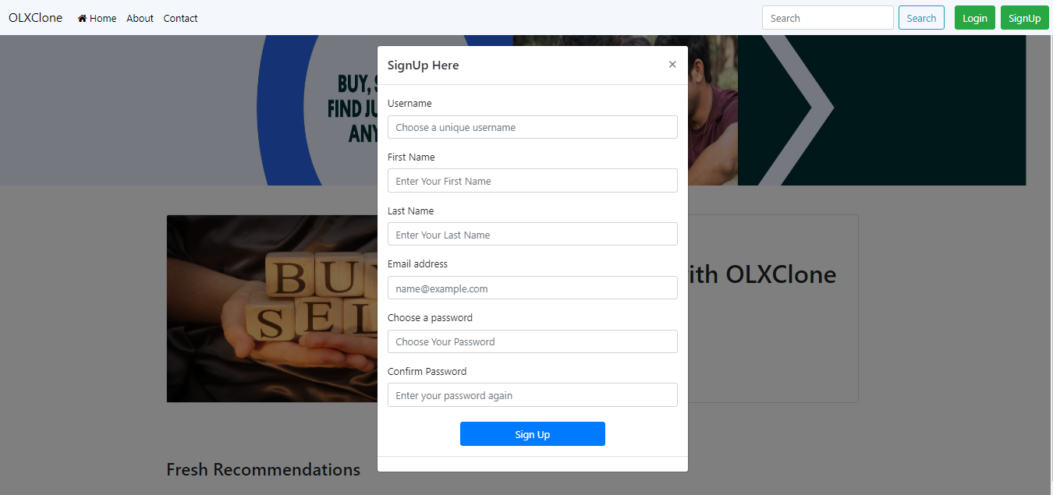

This is user register page

* Login Page

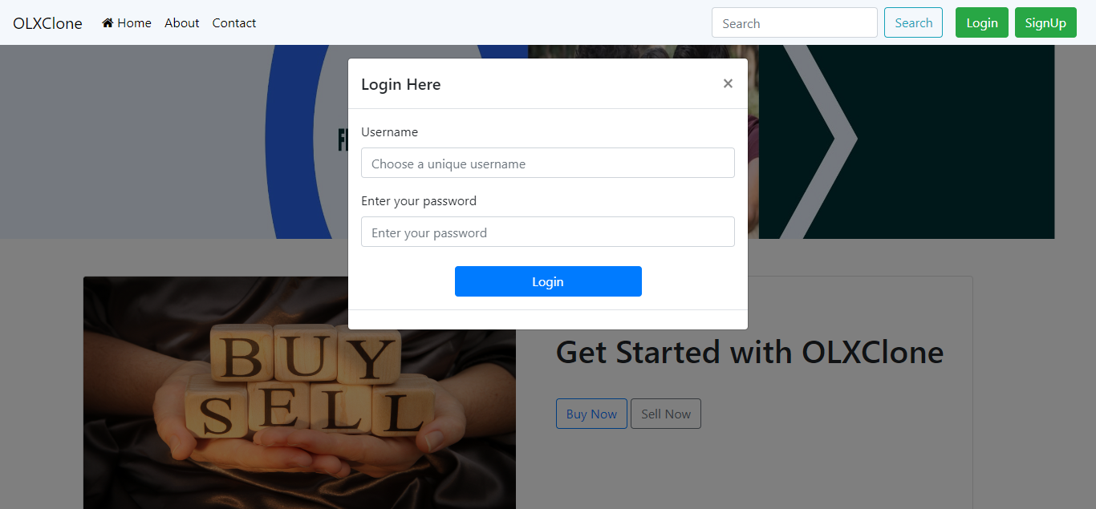

This is login page

* Home Page

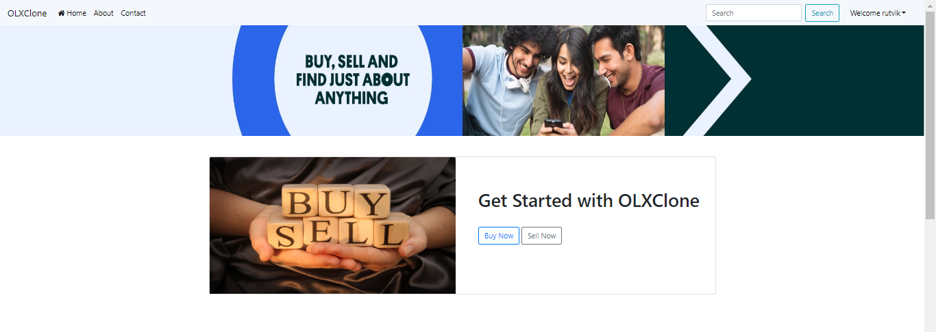

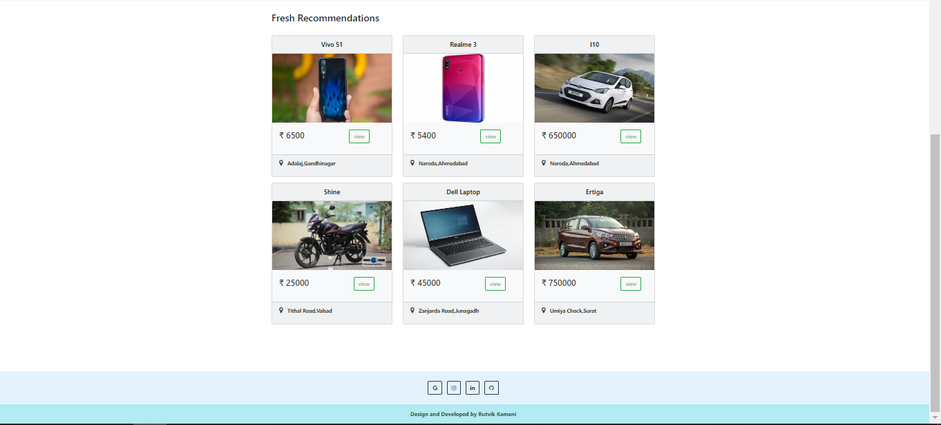

This is user home page

* Search Product

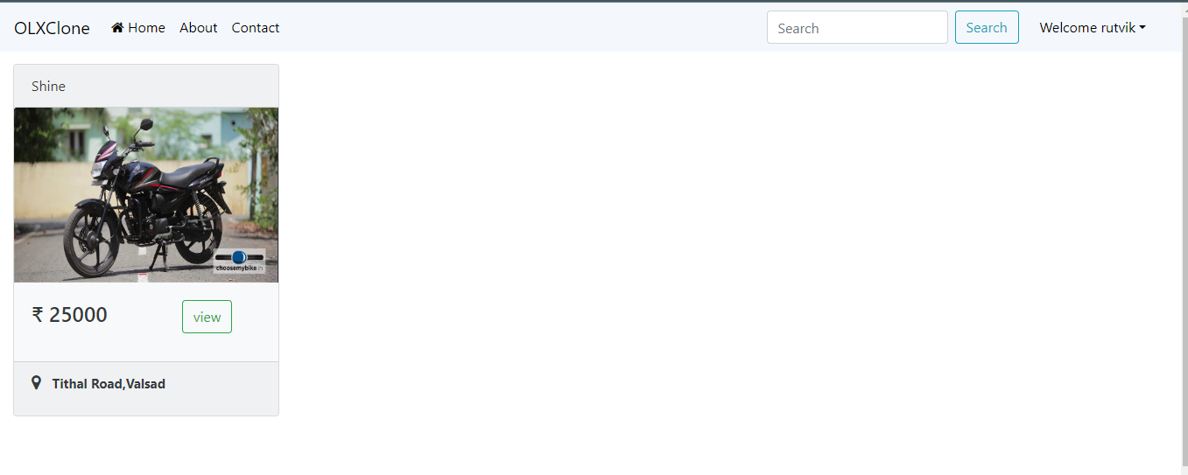

This is search product page

* Sell Products

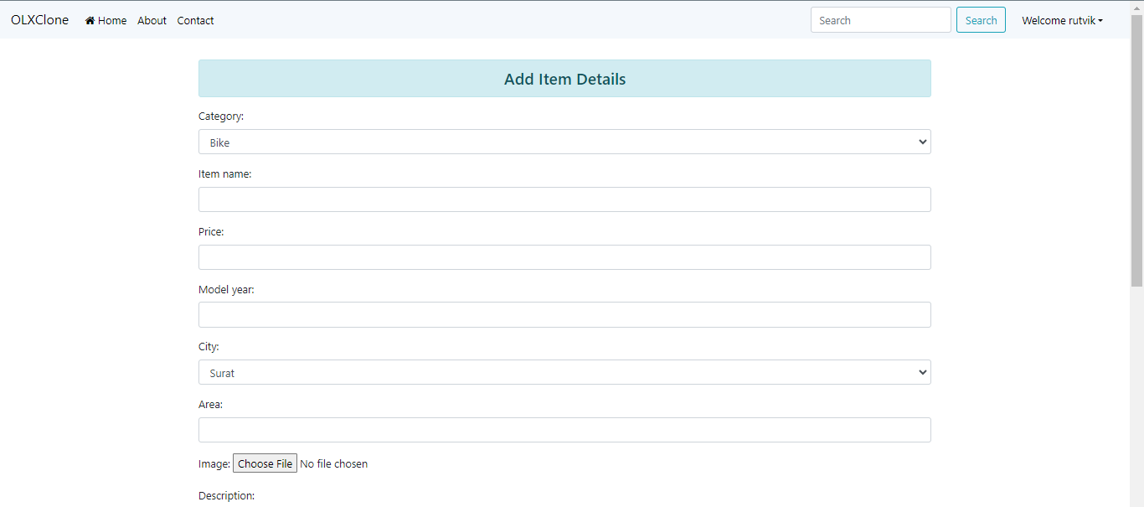

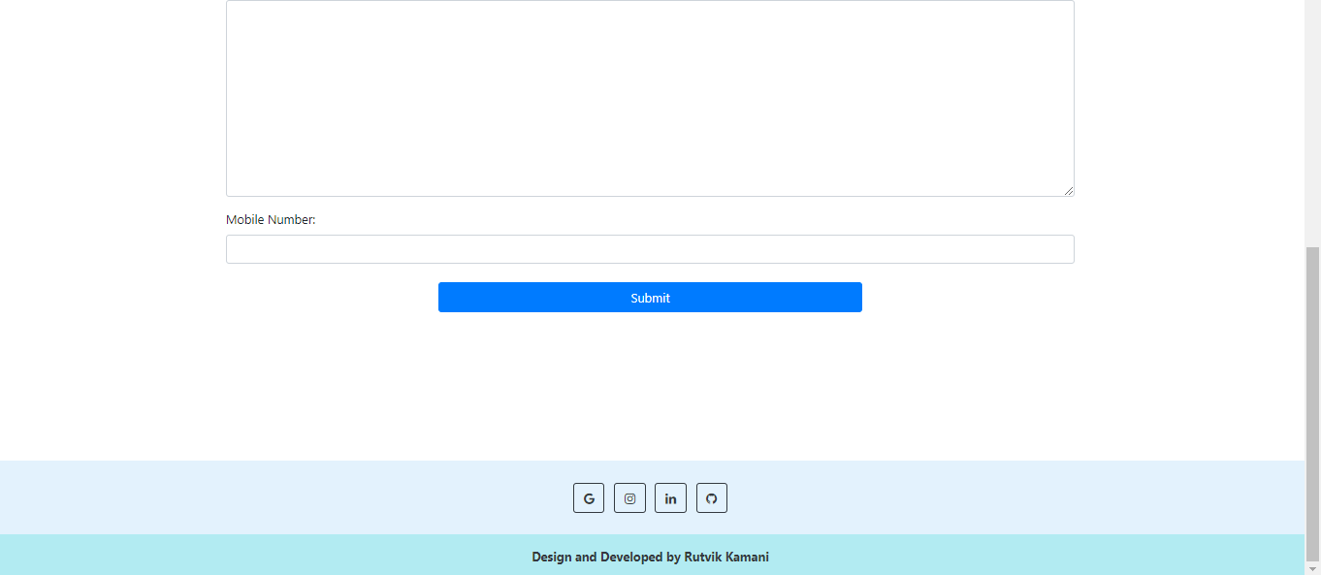

This is sell product page

* Buy Products

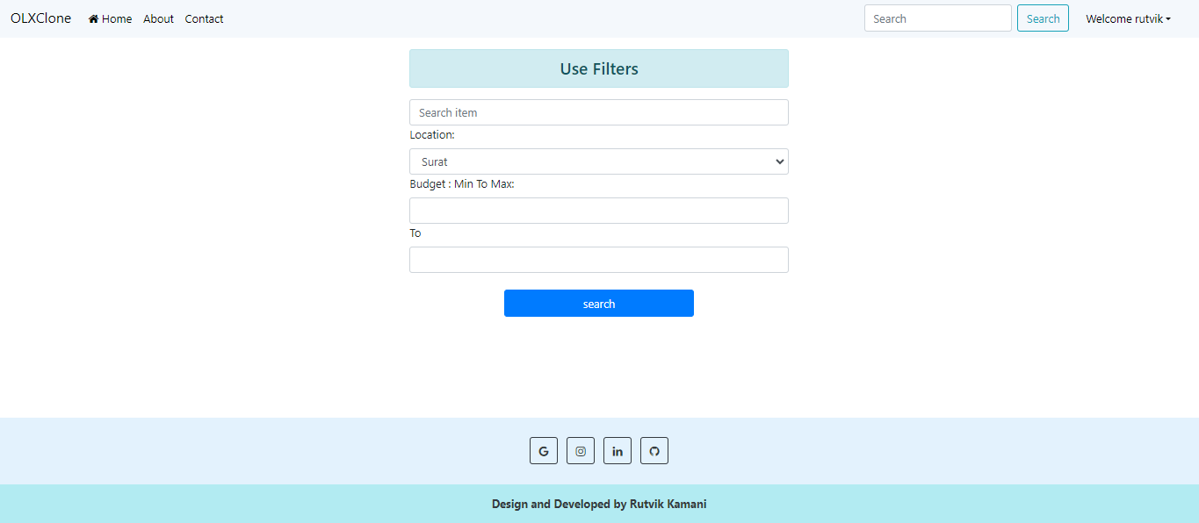

This is buy product page

* Product Description

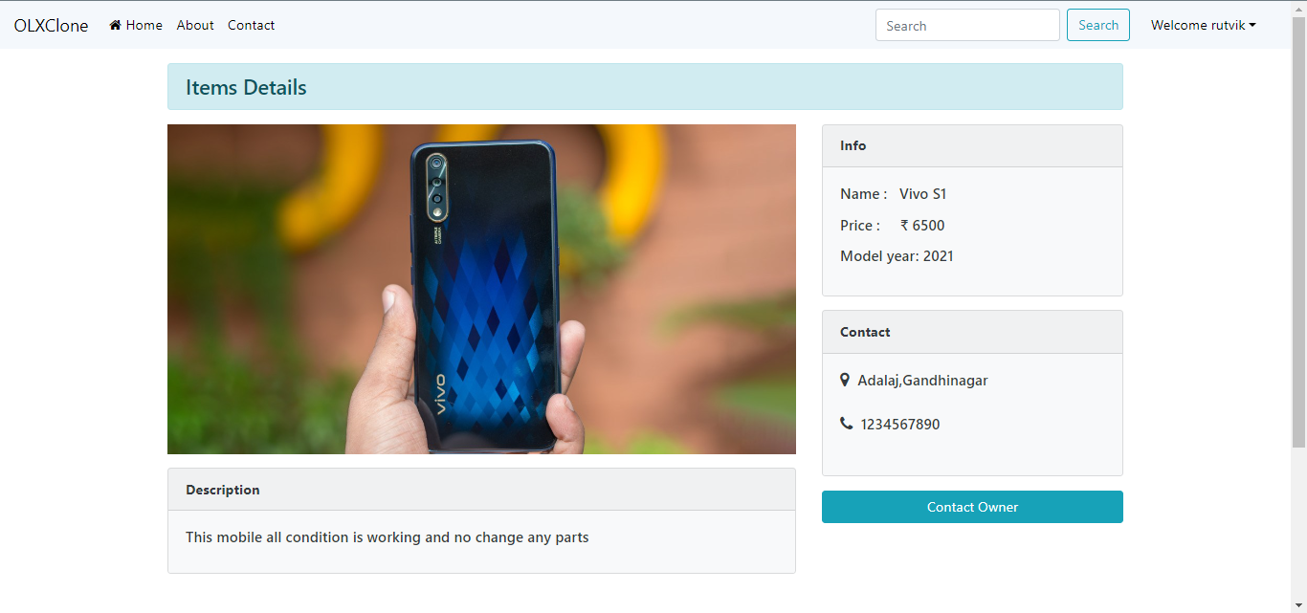

This is product description page

* About Page

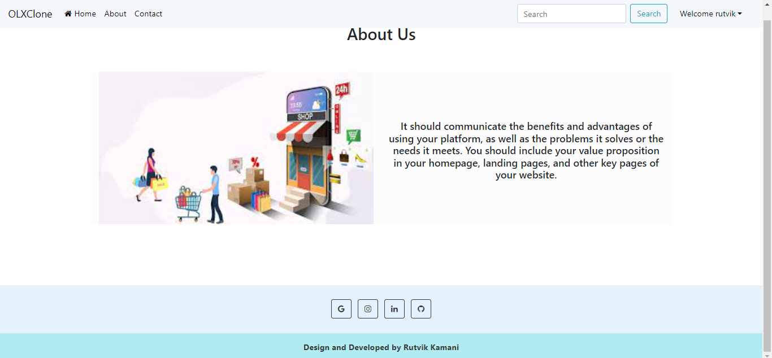

This is about us page

* Contact Page

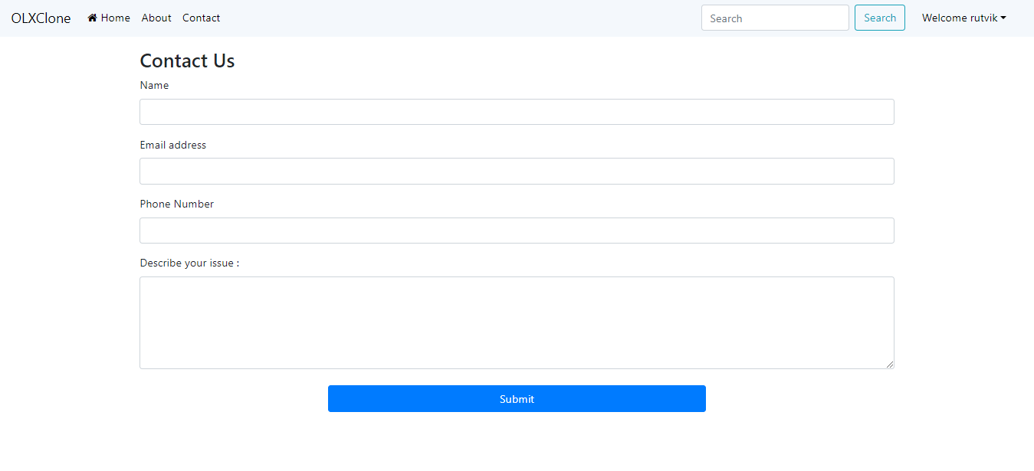

This is contact page

* Add all product for user

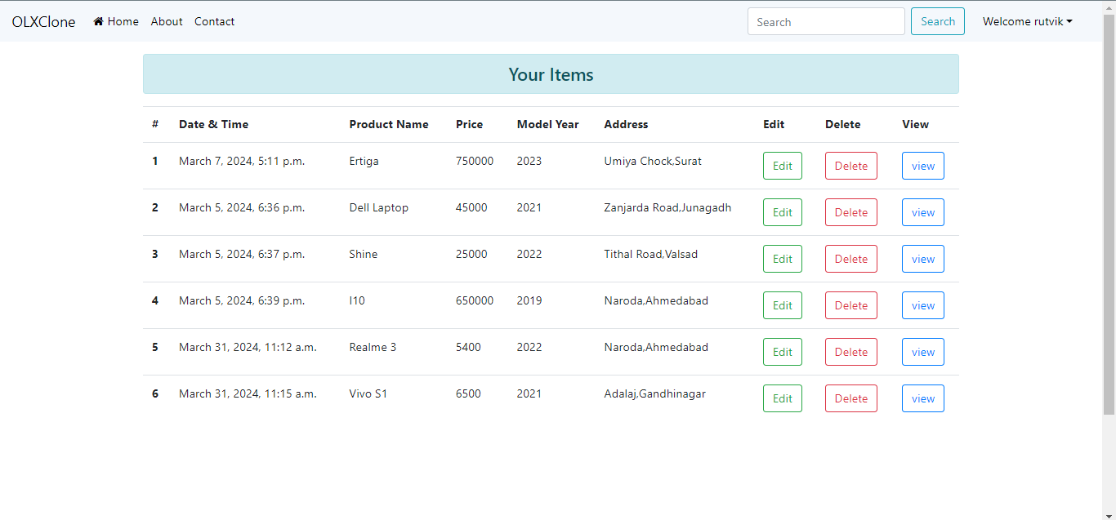

Add user all product show

* Update User Profile

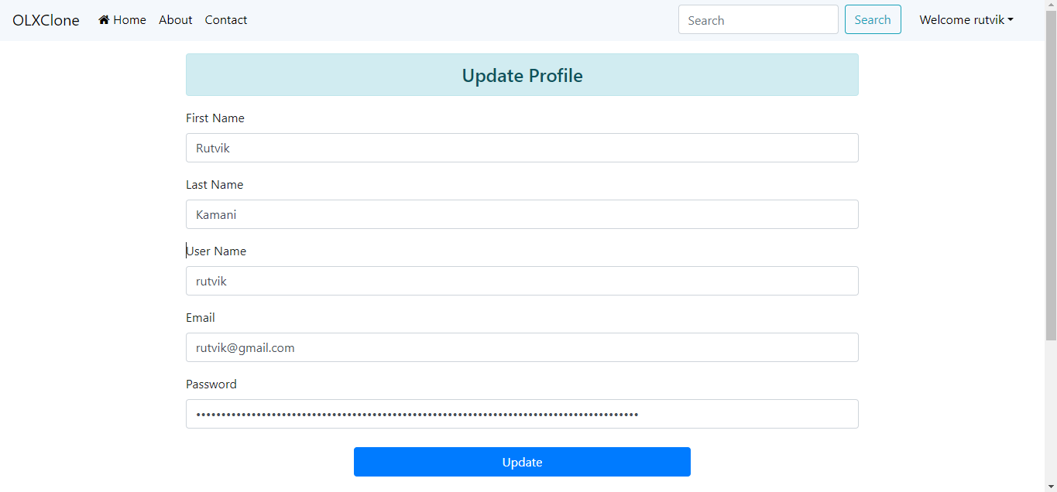

This is user profile page

* Admin Panel

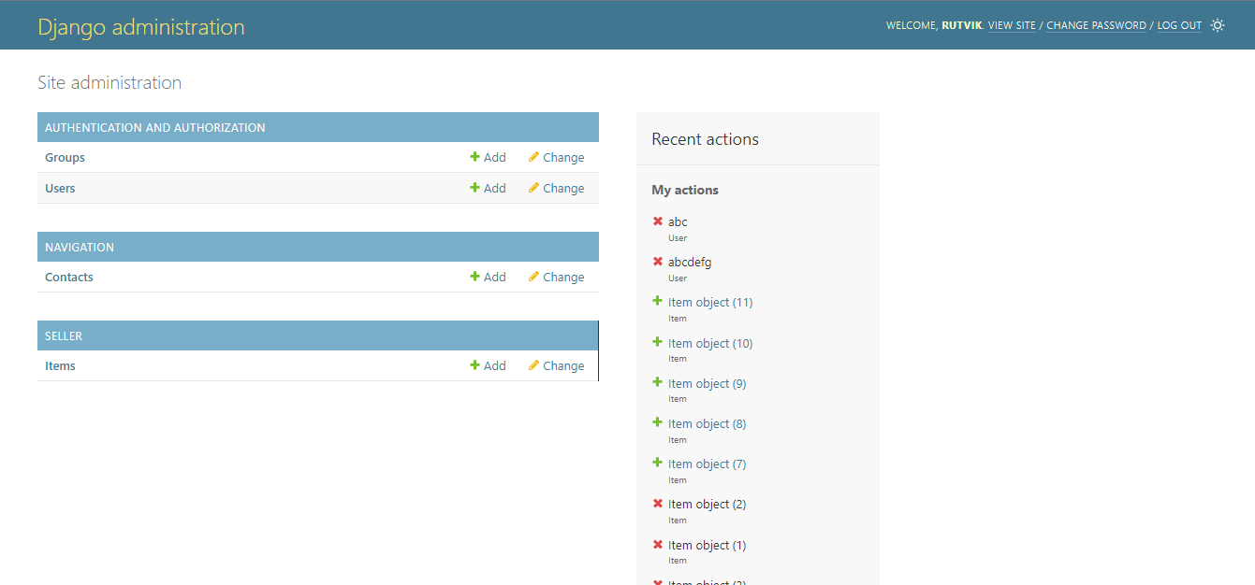

This is admin panel page

* Admin Contact Page

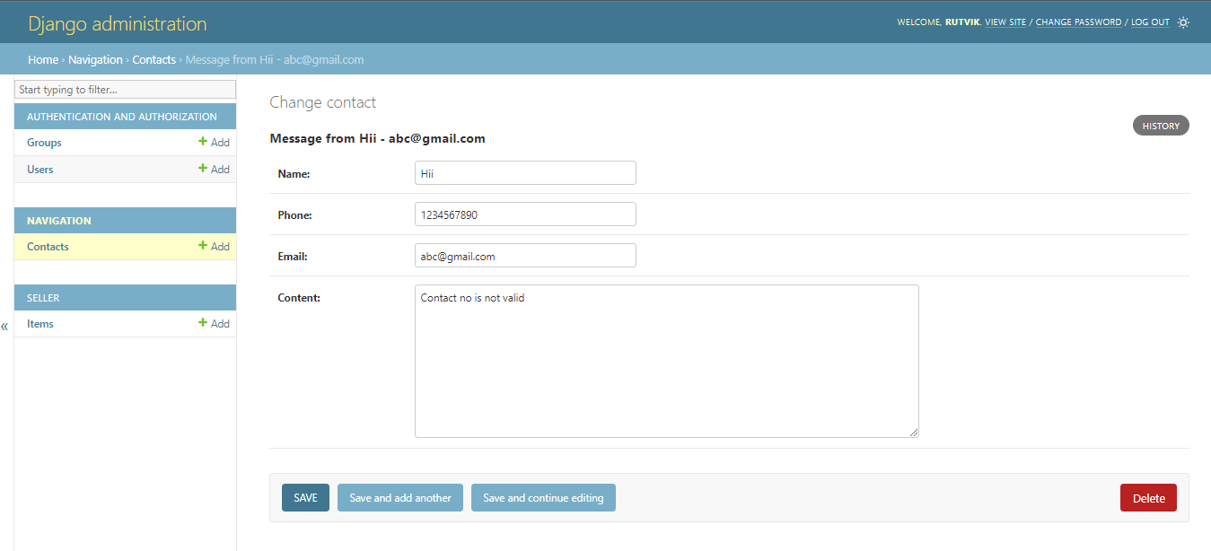

This is show user message contact page

* Show product details page

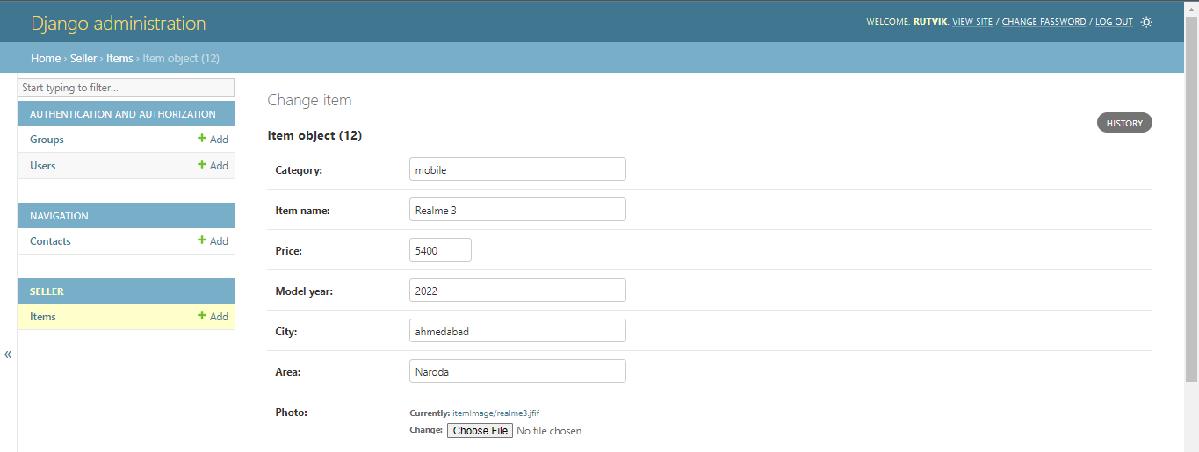

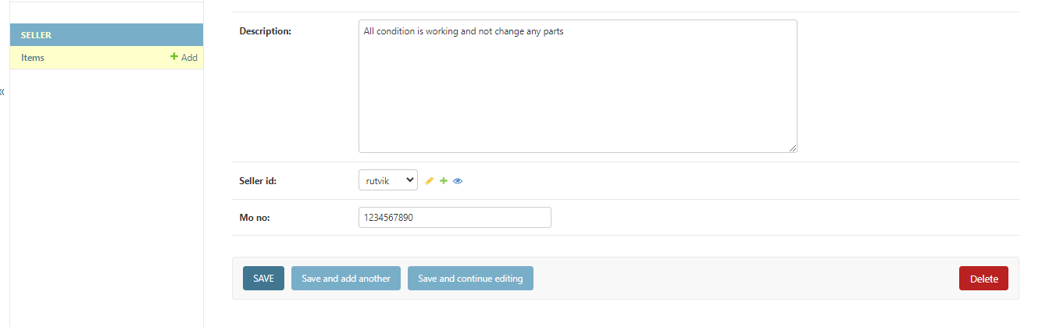

This is show product details page

**Limitation & future enhancement**

* Currently, we have not implemented the chat functionality because lack of time. But we want to implement this chat functionality in upcoming time, so that if any buyer has some query related to price of the item or some other query related to the item then he will be able to interact with the seller of that item directly in the system by chat functionality very easily.
* Also we want to increase our system capability, so that more user can able to use our system. We will also improve some non-functional requirements of the system like safety, performance, supportability etc.

**Conclusion and discussion**

* The functionalities are implemented in system after understanding all the system modules according to the requirements. Functionalities that are successfully implemented in the system are:
  + Sign-up, Sign-in with necessary validation on required fields
  + Logout
  + Add item with necessary details
  + Update particular details of the item or whole item
  + Delete item
  + Filter items from all the items pricewise
  + Search items by city or item-name or both
  + Show required items directly or using filter or search
  + Total sold products by particular user
  + Contact to admin for any runtime issues
  + Profile Modification
* After the implementation and coding of system, manual and automated unit testing was performed on the system to determine the errors and possible flaws in the system.

**References**

* Search Engines
  + <https://www.google.com/>
* Visited Sites
  + <https://docs.djangoproject.com/en/4.1/>
  + <https://www.geeksforgeeks.org/django-tutorial/>
  + <https://stackoverflow.com/>
  + <https://getbootstrap.com/>